## Exercise 1.14.5: Dividing the Site

This website only has a homepage!

Your job is to add the following three files:

1. compiled.html

2. scripting.html

3. style.css

Make sure every html page has a title, and the stylesheet is linked.

In index.html, add a link to scripting.html (just like as shown for compiled.html) in the list provided. Add a link back to index.html at the bottom of compiled.html and scripting.html.

Use the following styles:

* body should have the font-family Arial
* li should have a font-size 18px.
* Links should be LightSeaGreen

The homepage should look like this:

|————————————————————————-|

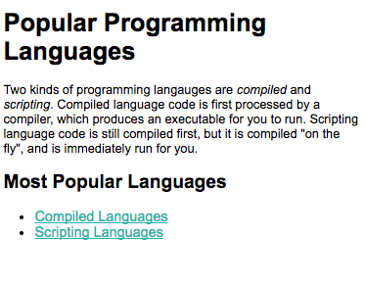

|————————————————————————-|

Put this list in compiled.html:

Java

C

C++

C#

The finished site will look like this:

|————————————————————————-|

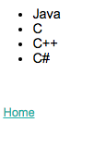

|————————————————————————-|

Put this list in scripting.html:

Python

JavaScript

Ruby

Perl

PHP

Visual Basic

The finished site will look like this:

|————————————————————————-|



